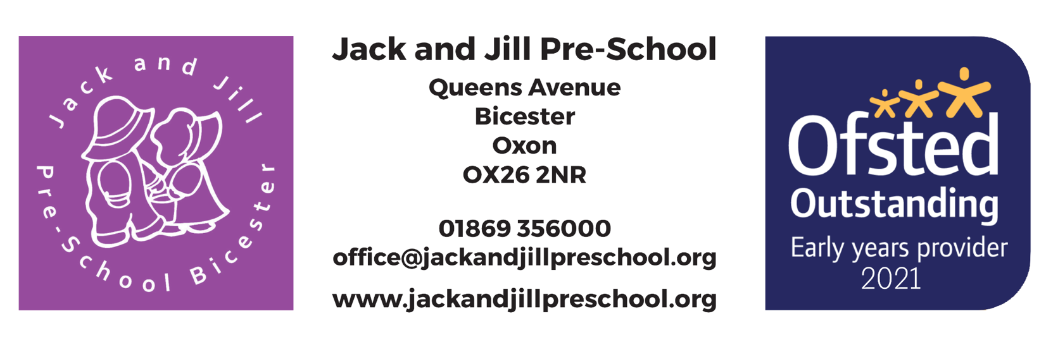

Welcome Pack

Pack Contents

- Pre-School Aims Statement

- About us

- Key person approach and attachments

- Contacting Pre-School

- Useful information

- Our Daily Routine

- Parent Mail

- Policies

Jack and Jill Pre-School
Aims Statement

We aim to provide a happy, stimulating environment, free from prejudice or discrimination, in which children can take their first steps in development and learning outside the home.
We follow the Early Years Foundation stage (EYFS) curriculum helping children to achieve the Early Learning goals.
There are 7 areas of the EYFS grouped into Prime and Specific. The Prime areas are Personal, Social and Emotional Development, Physical Development and Communication and Language. The Specific areas are Literacy, Expressive arts and Design, Mathematics and Understanding of the World.
We plan for themes that have stemmed from the interests of the children and current topics/celebrations and enhance the children’s learning by planning activities around these.

Our planning is flexible to change to meet the needs of the children as these interests can change regularly. Examples of these themes are The Kings Coronation, Chinese New Year, and other national events.

We encourage the enjoyment of books and stories, and children can choose a book from our lending library to take home with them on a weekly basis.
We can use our garden all year round to enjoy being outside and doing physical exercise.

Please visit our website for up-to-date policies and procedures. If you would like a paper copy of the policies, please ask a member of staff

www.jackandjillpreschool.org

About Us

The pre-school is a Charitable Incorporated Organisation run by Trustees and regulated by the Charities Commission.

The trustees employ the staff, who are responsible for all the children in their care and the day-to-day activities.
OFSTED registration
We are registered by OFSTED to offer early years education for up to 44 children daily. We have three rooms; the Beehive room can accommodate up to 10 children aged between 2 and 4, the Butterfly room can accommodate up to 24 children, aged between 2 and 4 and the Dragonfly room can accommodate up to 10 children aged between 2 and 4

We are inspected regularly by OFSTED Inspectors, at our last inspection (June 2021) we were graded OUTSTANDING in every area.

We are also a member of the Early Years Alliance, a voluntary body that is registered as an educational charity, and the Pre-School has adopted its constitution.
Staff
One Pre-School Manager, an Administrator, three Room Leaders and the required number of Early Years Practitioners are employed by the pre-school to give a high adult to child ratio at each session.
Jack and Jill Pre-school is an equal opportunities employer. Each member of staff and each trustee is checked by the disclosure and barring service. Any new members of staff, while waiting for police checks to be completed, are never left unsupervised with any child.
All staff undertake appropriate training to update their skills and underpin their knowledge and understanding of the needs of the pre-school.

Key Person & Attachment

The Key Person
Children thrive from a base of loving and secure relationships. This is normally provided by a child’s parents, but it can also be provided by a key person. A key person is a named member of staff with responsibilities for a small group of children who helps those children in the group feel safe and cared for. The role is an important one and an approach set out in the EYFS which is working successfully in settings. It involves the key person in responding sensitively to children’s feelings and behaviours and meeting emotional needs by giving reassurance, such as when they are new to a setting and supporting the child’s well-being. The key person supports physical needs too, helping with issues like nappy changing, toileting, and dressing. That person is a familiar figure who is accessible and available as a point of contact for parents and one who builds relationships with the child and parents or carers.
Records of development and care are created and shared by the key person, parents, and the child. Small groups foster close bonds between the child and the key person in a way that large groups cannot easily do. These groups allow the key person to better ‘tune into’ children’s play and their conversations to really get to know the children in the group well. Children feel settled and happy and are more confident
to explore and as a result become more capable learners.

Why Attachment Matters
What is attachment and why is it important for young children? Attachments are the emotional bonds that young children develop with parents and other carers such as their key person. Children with strong early attachments cry less when separated. They engage in more pretend play and sustain attention for longer. They are less aggressive and are popular with other children and with adults. Their sense of who they are is strong. Children need to be safe in the relationship they have with parents or carers. They are vulnerable but will develop resilience when their physical and psychological well-being is protected by an adult. Being emotionally attached to such an adult helps the child feel secure that the person they depend on is there for them. When children feel safe, they are more inclined to try things out and be more independent. They are confident to express their ideas and feelings and feel good about themselves. Attachment influences a child’s immediate all-round development and future relationships.

Contacting Pre-School

Pre-School telephone: 01869 356000

office@jackandjillpreschool.org

Jack and Jill Parents Group on Facebook – this is a closed group, and you will require permission from an admin to gain access to the page. We will only accept parents or carers into the group once your child has started, and you will need to verify who you are if not easily identifiable by your profile.

Please contact us either by telephone or email to let us know of a change of arrangements or if you will be late in collecting your child.

Please note – you must contact pre-school to inform us if your child is going to be absent. You can report absences via ParentMail, email or telephone.

To report abuse or if you have any concerns regarding a child, please visit Report abuse | NSPCC or call
- Office hours (8.30am – 5pm, Monday to Thursday, 8.30am – 4pm, Friday): Multi-Agency Safeguarding Hub: 0345 050 7666
- Outside office hours: Emergency Duty Team: 0800 833 408

Useful information

Toileting
If your child is still in nappies, we will be happy to assist you in the transition to toilet training. We will communicate to you when your child is showing signs of “being ready” to make this transition. However, we will not under any circumstances put pressure on any parent/carer to follow this advice and respect that the parent knows their own child.
Please provide a full change of clothes and all the usual nappy changing requirements. We do have spare clothes but have found children are much happier when put into their own.
Your child’s individual needs will be discussed with your Key Person on your introduction telephone call.

Promoting independence
We aim for children to enjoy the company of others, be confident expressing themselves, and gain the ability to follow and complete simple tasks such as using the toilet, washing, and drying their hands, putting on their own coats, listening to and following instructions and suggesting to staff what they would like to do in Pre-School. The children enjoy the feeling of achievement and are continually praised by staff to acknowledge these achievements.
Gaining some independence is relevant to your child’s development and helps to prepare the child for the Nursery environment.

Jack and Jill Pre-School Clothing Policy
Please send your child to pre-school in comfortable clothes that they can easily manage when using the toilet. Please do not send your child in clothing that you will be disappointed if it gets splashes of glue or paint on as this is inevitable.
Please provide your child with a complete change of clothing that we will keep in a named bag at preschool as we encourage as much independence as possible, and accidents will happen from time to time.

Cold weather
It is recommended that your child wears a warm jumper/fleece to pre-school; short sleeves are usually not enough.
If your child comes to pre-school in boots, please bring a change of shoes.
Your child must always wear something on their feet whilst in pre-school.
Please ensure that your child is wrapped up warmly for outside play as we use the garden all year round.

Hot weather
The outside play area will be used in hot weather and protection is imperative. We cannot take your child outside without protection. We will send home a separate letter regarding suncream.
Long sleeves are another protection option. It is also advisable for your child to wear a sun hat.

Snacks and Lunches
Please provide your child daily with a healthy snack such as fruit or yoghurt, and a healthy balanced lunch box. If you are unsure of what to put into your child’s lunch box, please have a chat with your child’s key worker who will be able to advise you or visit. For an additional fee we can supply lunches, more information will be sent to you.

www.nhs.uk/change4life/recipes/healthier-lunchboxes

A typical day at Jack and Jill Pre-school

We are open from 8.30 am and close at 2.50 pm parents can drop off until 8.50 am and collect from 2.30 pm

The daily routine at a glance

Time | Activity
08:30 am – 08:50 am | Arrival
09:45 am - 11:30 am | Educational children's programme to include free flow
12.00 pm - 12:30 pm | Lunch
1:00 pm - 2:00 pm | Free play to include free flow
2:15 pm - 2:30 pm | Tidy up time
2:30 pm - 2:50 pm | Song time
2:50 pm | All children must be picked up as pre-school closes

Improving School Communications with ParentMail

Communicating with parents is an important part of what we do, making sure you get the correct information about activities, events and things that really matter is something we care about.
We use ParentMail, a service used by over 6,000 schools, nurseries, and children’s clubs to communicate to parents. ParentMail is beneficial to you because you can:
- Use a free mobile app on Android and iOS to pick up school messages instantly.
- Pay invoices in just a few taps.
- Complete forms, give consent/permissions and give feedback on surveys.
- Keep on top of school meetings and events.
- Book parents’ evening appointments.
- And much, much more!

Registering with ParentMail is very easy! You will be sent either an email and/or text message from ParentMail, when you receive this, please just follow the instructions in the message.
Please be assured that ParentMail is registered with the Information Commissioner and guarantees that all information you provide will be kept private and will not be passed on to any other organisation.
Once registered, if you have an Android or Apple smartphone, we highly recommend you download the ParentMail App for the best user experience. To do this, simply search for “ParentMail” in your App store.
If you need any additional information or assistance, please visit the help site: https://www.parentmail.co.uk/help/parenthelp/ or if you have not received any contact from ParentMail please contact the pre-school office.

Our policies can be found on our website
www.jackandjillpreschool.org

