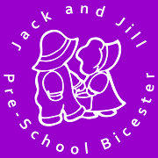
Promoting health and hygiene
1.18 No-smoking

Policy statement
We comply with health and safety regulations and the Welfare Requirements of the EYFS in making our setting a no-smoking environment - both indoor and outdoor.

Procedures
- All staff, parents and volunteers are made aware of our no-smoking policy.
- We display no-smoking signs.
- The no-smoking policy is stated in our information brochure for parents.
- We actively encourage no-smoking by having information for parents and staff about where to get help to stop smoking if they are seeking this information.
- Staff who smoke do not do so during working hours. Unless on a break and off the premises.
- Staff who smoke during their break make every effort to reduce the effect of the odour and lingering effects of passive smoking for children and colleagues.

Legal framework

- The Smoke-free (Premises and Enforcement) Regulations 2006
- The Smoke-free (Signs) Regulations 2007

This policy was adopted at a meeting of | Jack and Jill Pre-school | name of setting
Held on | August 2023 | (date)
Date to be reviewed | August 2024 | (date)
Signed on behalf of the management committee
Name of signatory | Laura Collier
Role of signatory (e.g. chair/owner) | Chair

